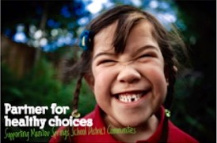
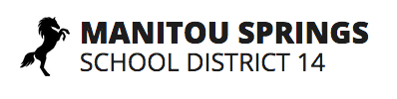
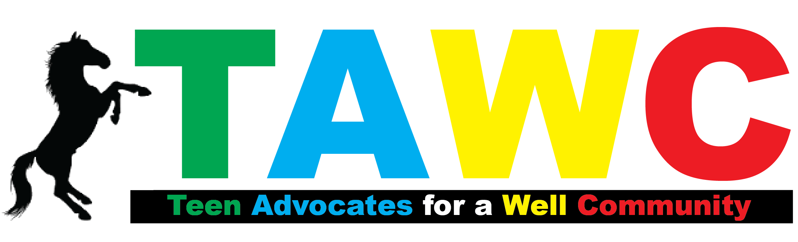

PARENT-CHILD AGREEMENT

This agreement is initiated by the MSSD 14 Teen Advocates for a Well Community (TAWC), a student wellness group at Manitou Springs High School. TAWC hopes to facilitate conversations between parents and their young students regarding decisions they make relating to alcohol, drugs, peer pressure, and behavior. Many times, the issues young people face can be difficult for them to address. TAWC believes that an effective parent-child conversation will assist in young adults making better decisions.

As your child ________________________, I understand that alcohol/drugs can harm my body and mind and can jeopardize my future prospects. I pledge to avoid situations where drug and alcohol use could pose a threat on my well-being or that of others. I promise to call or text you to pick me up from situations where myself or my peers are engaging in these behaviors.

By signing this pledge, I agree to keep myself safe from the harms of underage drinking and drug use.

As your parent(s)/guardian _________________________________, I pledge to do my part in helping keep you responsible and safe. I promise to talk with you about the dangers and harmful effects of underage drinking and drug use, and to create a safe environment for you and your friends. I also pledge to pick you up at any time or place if you find yourself in any uncomfortable situation where underage drinking or drug use is involved.

By signing this pledge, I agree that I will engage in constructive conversations with you about the dangers of underage drinking and drug use.

______________________________ _______________________________
Child Parent(s)/Guardian

